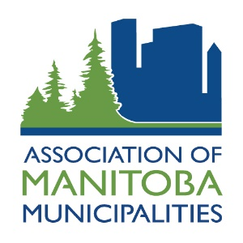

AMM CORPORATE MEMBERSHIP
This letter is to introduce you to the importance of becoming a Corporate Member with the Association of Manitoba Municipalities (AMM), an organization representing all 198 municipalities in Manitoba.
We invite both commercial and non-profit organizations to become AMM Corporate Members. Corporate membership enables you to communicate with people who influence or make purchasing decisions for their municipalities; elected officials, administrative officers and public works officials. Manitoba municipalities spend millions of dollars on products and services each year.
By working with the AMM, you are guaranteed the
best possible access to the municipal market!

BENEFITS
There are many benefits to becoming an AMM Corporate Member, including:

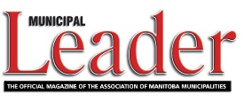
Publications
- You will receive a complimentary subscription to The Municipal Leader, a quarterly magazine read by more than 1,400 municipal officials, administrators and others involved in municipal government.
- You will also receive the AMM News Bulletin, our bi-weekly update on AMM activities and events.

Municipal Events
The AMM holds a variety of municipal events throughout the year, including:
- AMM Annual Convention - Held each November, this event provides you with an opportunity to make valuable business contacts. You will be given an opportunity to obtain space at the Display Area during Convention.
You will also be given the opportunity to advertise in the Official Convention Handbook, distributed to each of the 1,000+ delegates. Only Corporate Members and Official Suppliers are given the opportunity.

- MTCML Trade Show - Held in conjunction with the AMM Municipal Officials Seminar each February, the MTCML Trade Show is the largest municipal trade show held in Manitoba, with over 100 booths.

You may also wish to bring your organization into the spotlight by sponsoring meals, receptions or other activities at AMM events.

